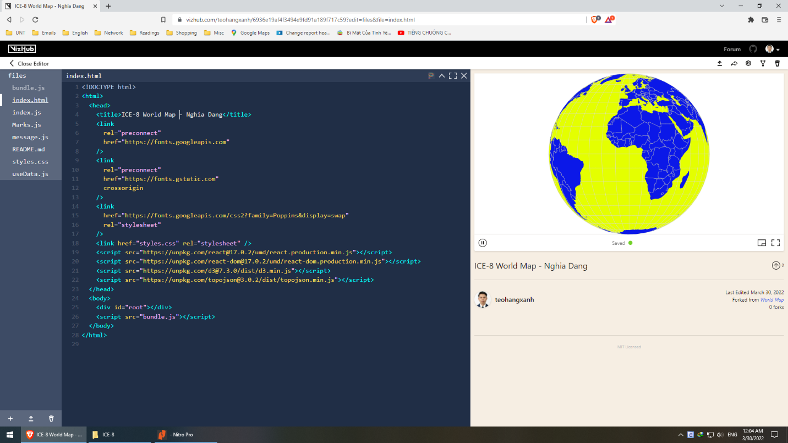

https://vizhub.com/teohangxanh/6936e19af4f3494e9fd91a189f717c59?edit=files&file=Marks.js

I use geoOrthographic as it is the regular shape people often represent.

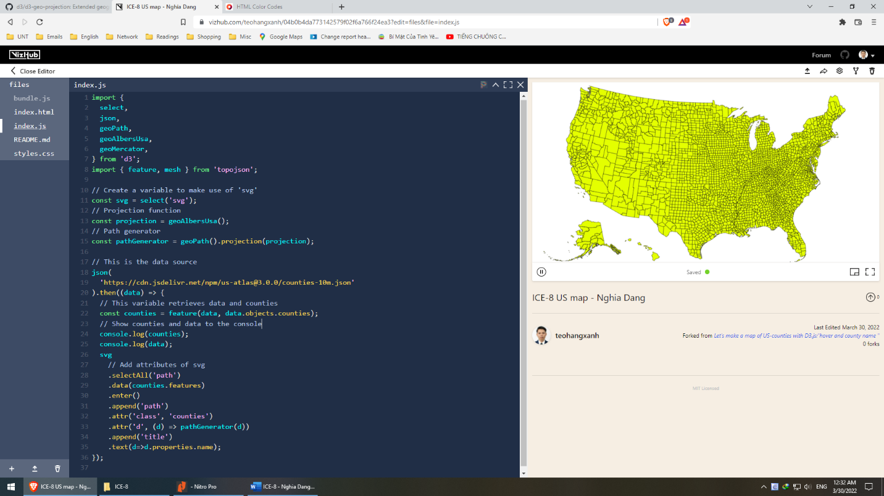

https://vizhub.com/teohangxanh/04b0b4da773142579f02f6a766f24ea3?edit=files&file=index.js

Even though the source is ‘https://cdn.jsdelivr.net/npm/us-atlas@3.0.0/counties-10m.json’, it belongs to Topojson from this Github repo <https://github.com/topojson/us-atlas>

I use geoAlbersUsa because it supports projecting US map

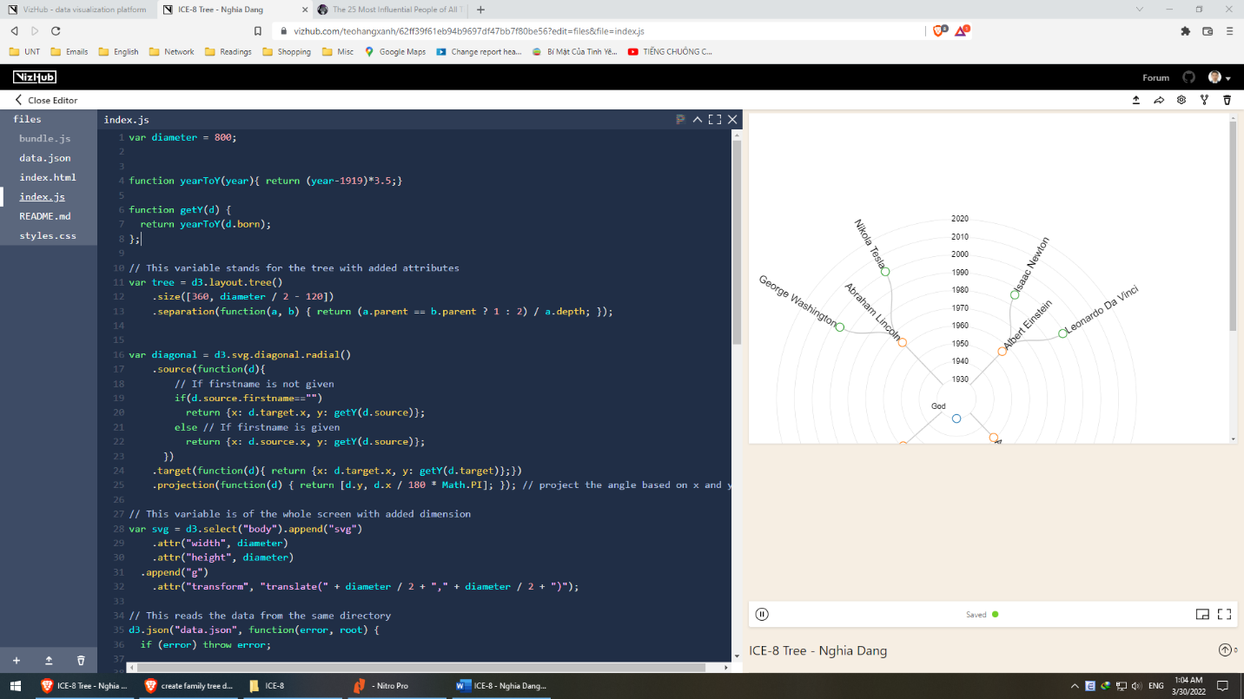

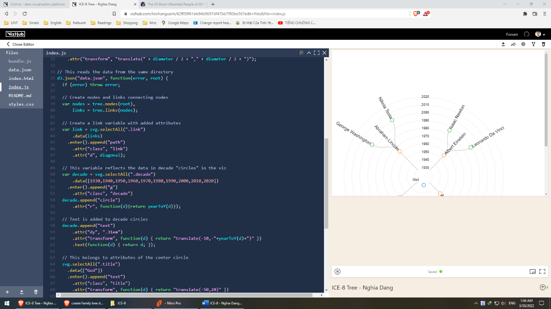

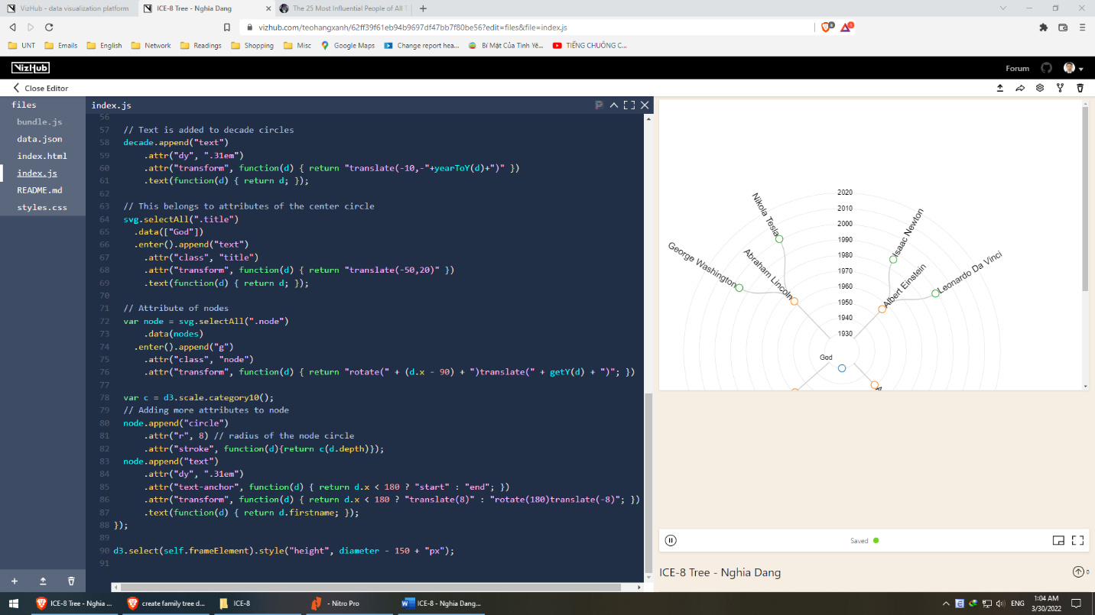

<https://vizhub.com/teohangxanh/62ff39f61eb94b9697df47bb7f80be56?edit=files&file=index.js>

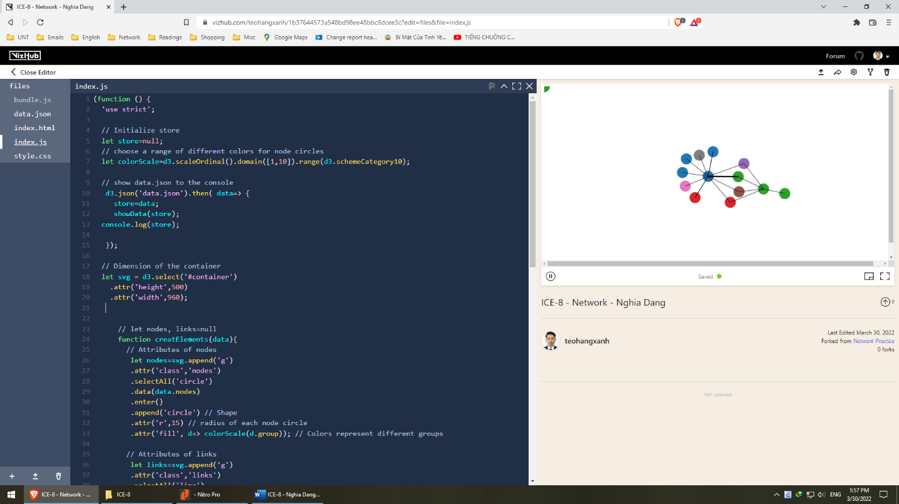

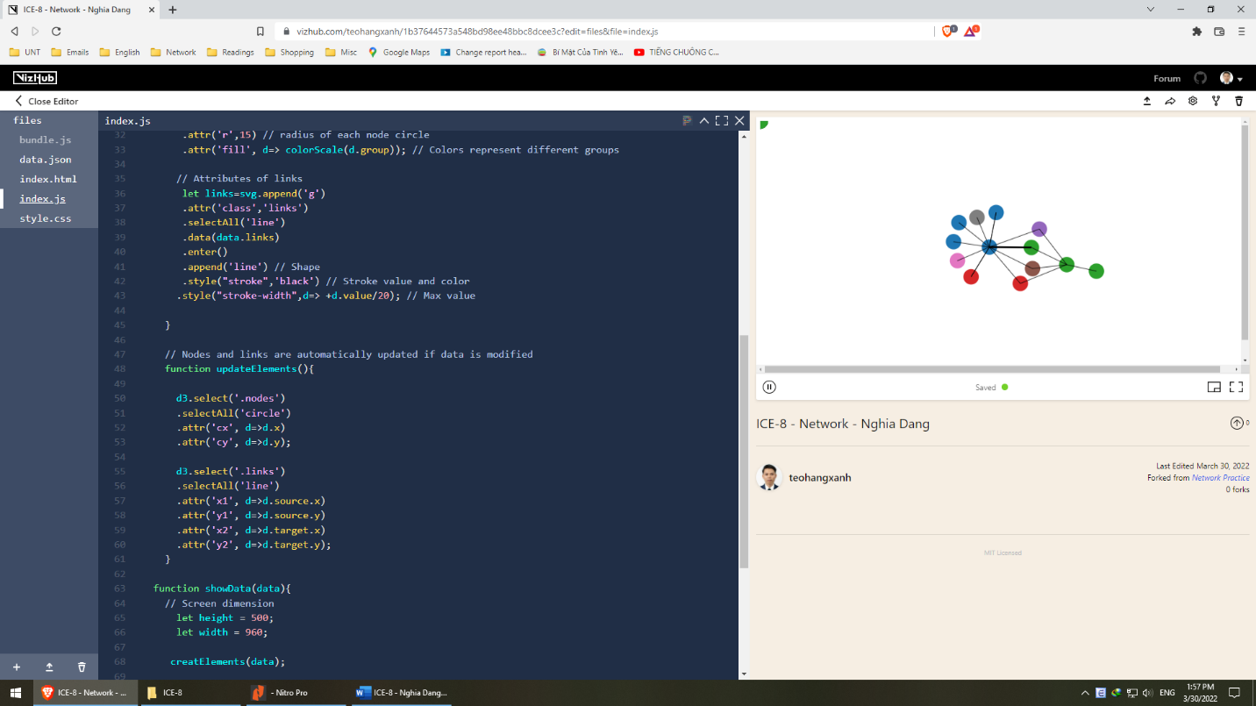

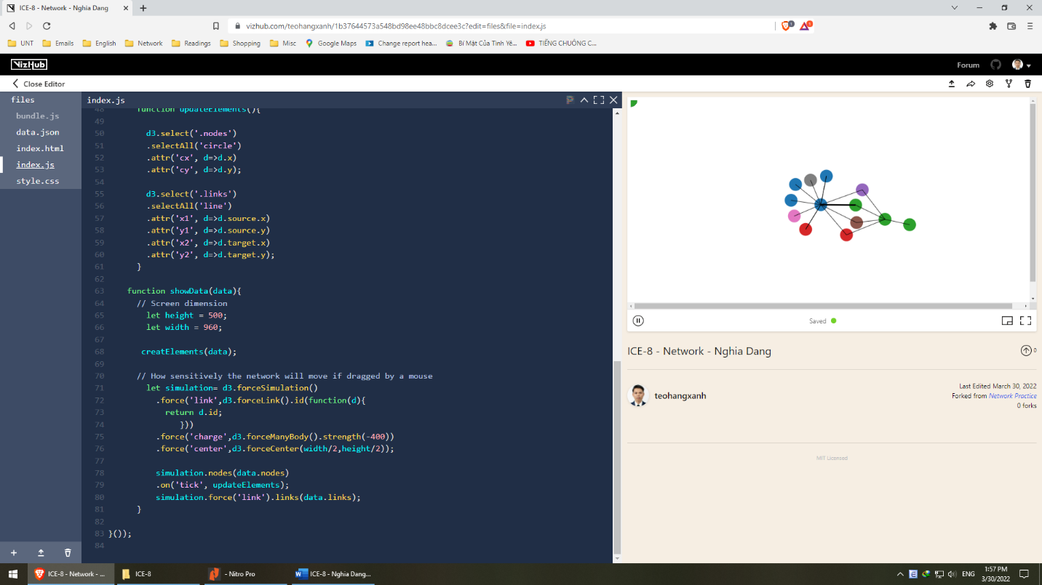

<https://vizhub.com/teohangxanh/1b37644573a548bd98ee48bbc8dcee3c?edit=files&file=index.js>

What are the differences between network and tree charts:

* Tree charts are hierarchical, in network charts, all nodes are at the same level
* A tree originates from a root (node) while in network, all nodes coexist.
* The relationship among nodes is commutative (A is B’s friend = B is A’s friend) while it is not in tree charts (A is B’s child is not equal to B is A’s child)

What kind of data should be visualized in a network chart but not in a tree? Give examples.

* As the above answer pointed out, data of which all relationship is nonhierarchical should be visualized in a network rather than a tree.